**Placement Empowerment Program**

***Cloud Computing and DevOps Centre***

**Use Cloud Storage**

*Create a storage bucket on your cloud platform and upload/download files. Configure access permissions for the bucket.*

Name: Jaswanth Saravanan Department : ADS



**Introduction:**

In this (PoC), we will explore AWS S3 (Simple Storage Service) to understand its functionality as a reliable cloud storage solution. The task involves creating an S3 bucket, uploading and downloading files, and configuring access permissions to manage who can access the stored data. This PoC demonstrates S3's versatility in securely storing and retrieving files, both publicly and privately. We will also set bucket policies to control access and test public URLs for hosted files. By completing this task, we gain hands-on experience with S3 and its key features, such as scalability, security, and cost-efficiency.

**Objective**

The goal of this project is to:

1. Understand AWS S3 Basics: Learn how to create, configure, and manage an S3 bucket for cloud storage.
2. File Operations: Gain hands-on experience in uploading, downloading, and managing files within the S3 bucket.
3. Access Control: Configure bucket policies and permissions to manage secure and public access to stored data.

**Step-by-Step Overview:**

**Step 1:**

**Go to the AWS Management Console, Search for and click on S3,** **Click the "Create bucket" button**

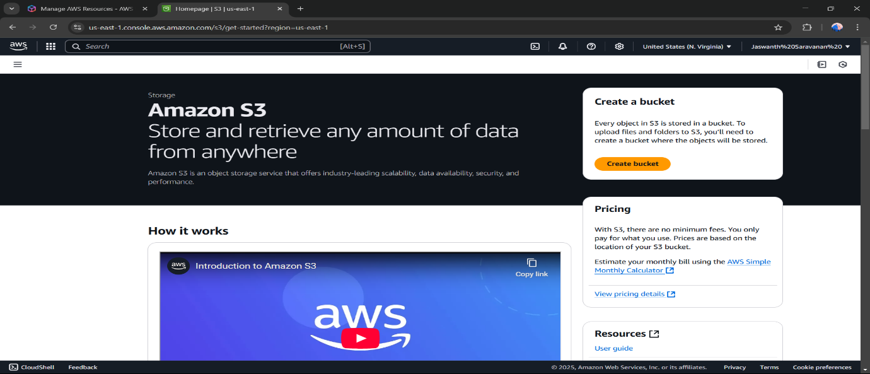

Step 2:

Enter a unique bucket name for the bucket that you want.

Step 4:

In step 4 disable all the Block all public Access.

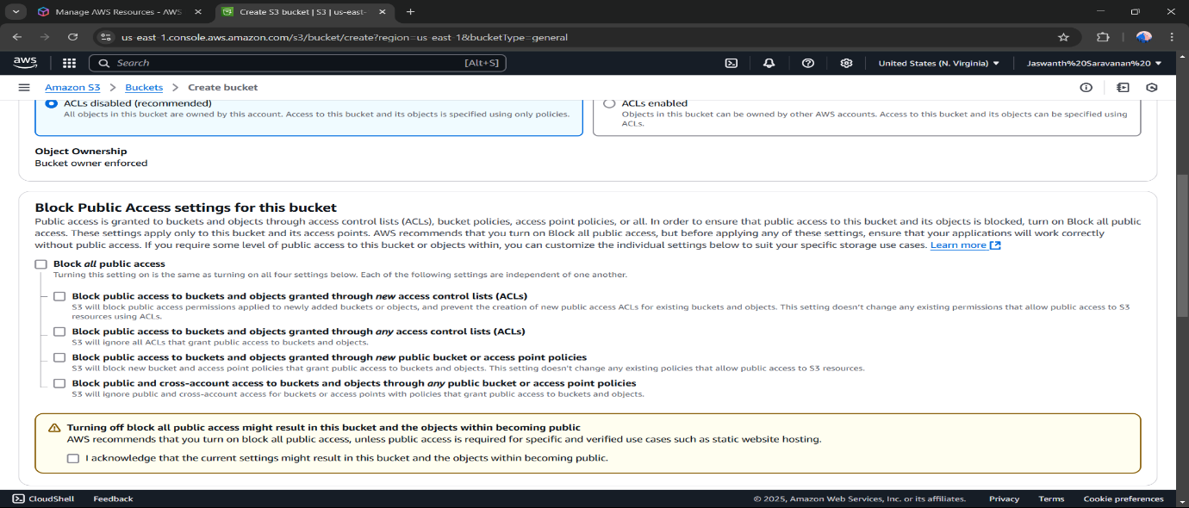

Step 5:

Scroll down and select the Create Bucket , so your bucket will be created .

Step 6 :

Move to Permission region and allow bucket policy .

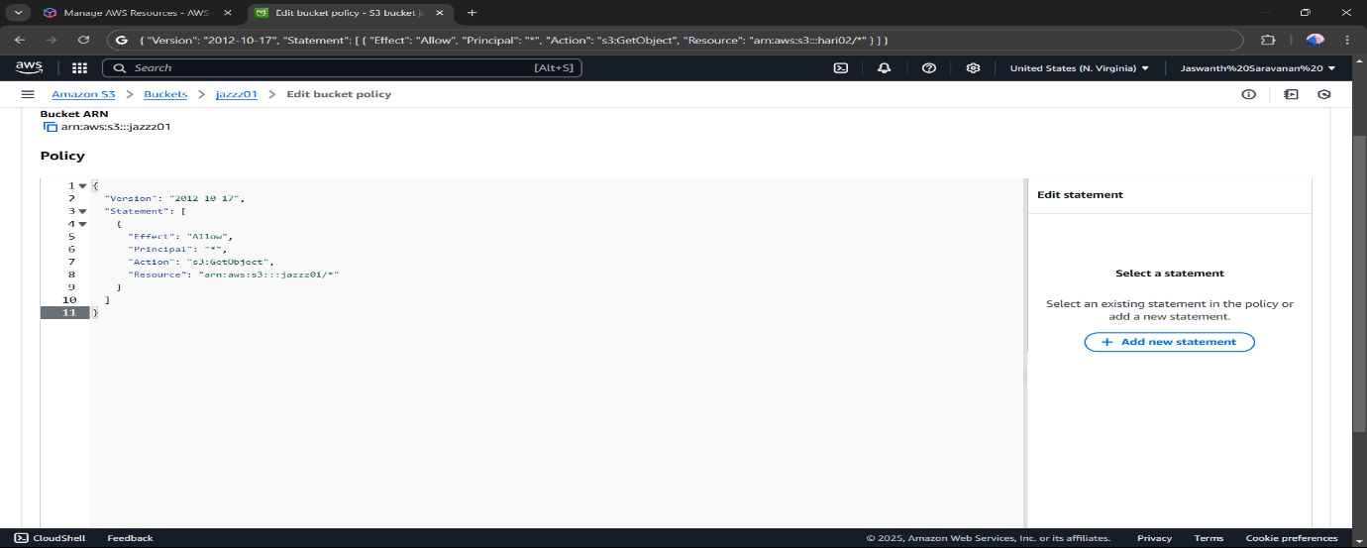

Step 7:

Click "Upload" and then,

Drag and drop your file(s) or use the Add files button.Click Upload to complete.

Step 8:

Move to the Properties region and copy the url to access url permission , so that the url can be pasted in the browser .

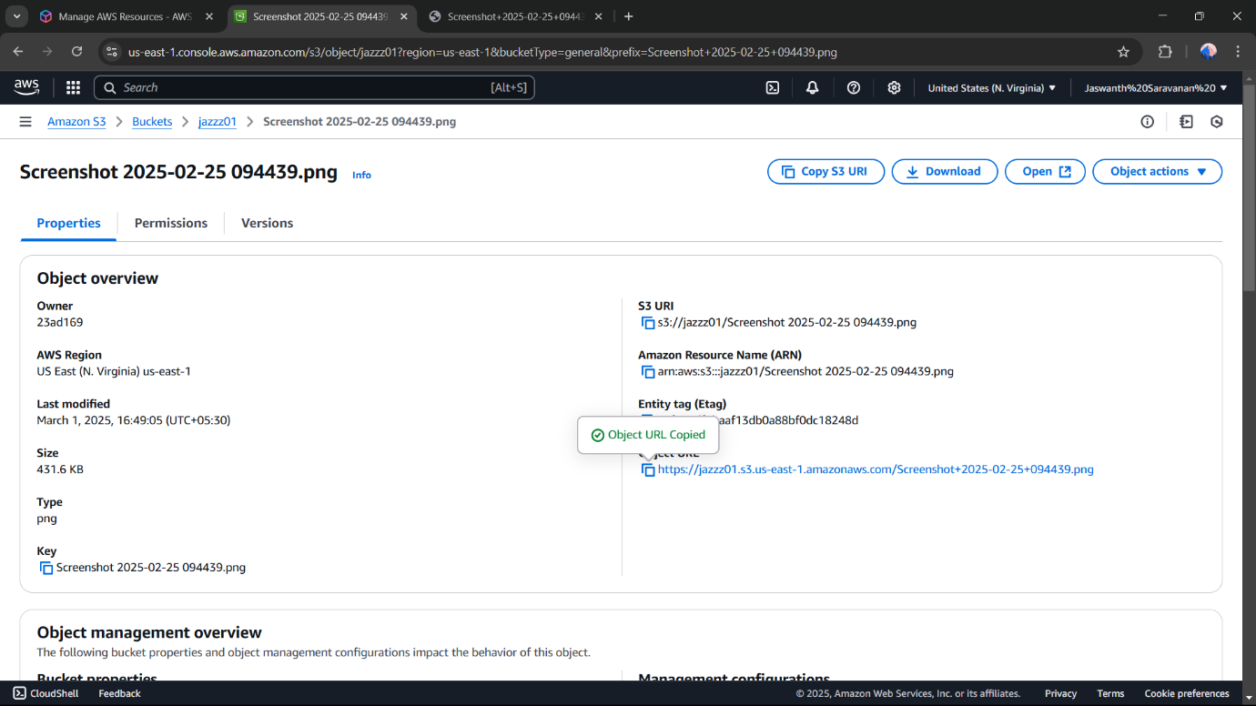

Step 9:

After pasting the url in the browser , you can allow permission .

